-------------------------------------------------------------------------------------------------------------------------------NAME: ARCHANA DEVI.P
REG NO: 192521192
COURSE: SOFTWARE TESTING
CODE: CSA0923
LAB PROGRAMS
Question 23: Sum of Digits Using White-Box Testing

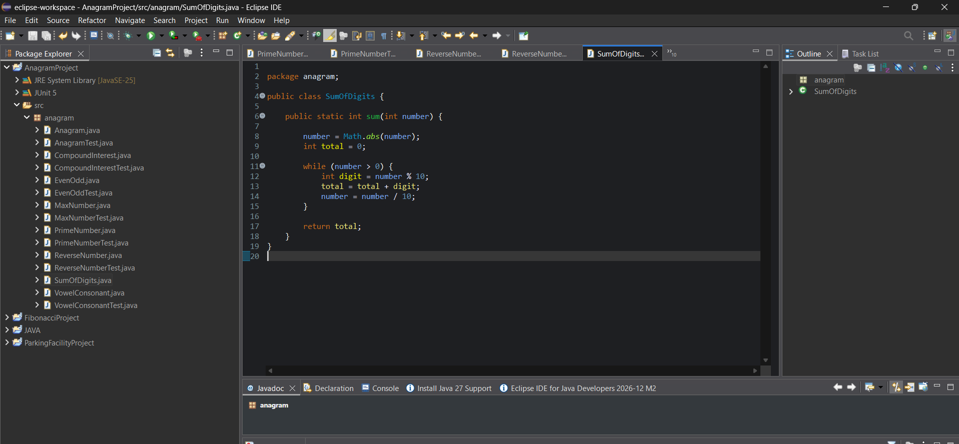

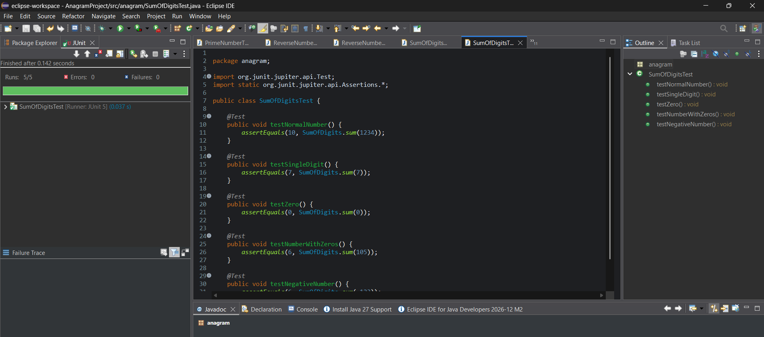
White-box testing
The tests cover:
- Multiple iterations of the loop.
- A single-digit number.
- Zero, where the loop does not execute.
- Digits containing zero.
- Negative input.
Result:
The sum-of-digits program was implemented successfully and tested using JUnit 5. Five test cases validate the calculation and different loop execution paths.

